Appendix 5: New Features in Version 3.4 B
Here is a brief listing of some of the features new in Version 3.4 B:
- Program has several new Example vehicle files, including an all electric Tesla, most with picture files. Fig A12.
- Program now allows for 4 more trans ratios so you can specify up to 10 speed transmissions, either manual or automatic in Transmission Specs. Fig A13.
- You can now specify an automatic torque converter to lock up at some particular gear ratio. At that gear ratio and all higher gears, the converter is assumed to remain locked. Fig A13.
- Program now also has 4 more gear shift RPMs in Driving Specs screen. Fig A14
- Added a setting for number of gears in the transmission, and program now hides gear ratios not needed. This makes it more clear how the program is using transmission gears. Prior to v3.4B, the program just looked for a blank or zero input for a ratio to know that gear was not being used. Fig A13
- Now, if the program finds that converter is too loose for a combination User Selected shift RPMs and the particular power curve, the program now switches to Computer Picked Shift RPMs so the calculations can continue.
- The program now has greatly enhanced graphing options, similar to our larger programs. You can overlay more runs, zoom in, specify grid layout, have more printout and labeling options, and much more. Figs A15 through A27.
- Now when you delete a file, it now goes to the Recycle Bin so you can 'recover it later if you need to. Fig A29 and Fig A30.
- The program now has an “'Advanced” button for saving or opening data files or external drives or other folders on your computer. Fig A28
- The program now better checks for some values for producing errors and fixes the problems so the calculations can continue, without producing error messages.
- Program now has a “Compress Picture File” as a File option for pictures, which explains how to compress picture files with 3rd party program.
- Program now better handles direct drive transmission and 1 gear transmissions.
- You can now retrieve files from History Log.
- Program now better deals with external drives for saving and opening files, and no longer calls them "Floppy Disks".
- Program now saves more of the graph settings for printing and comments.

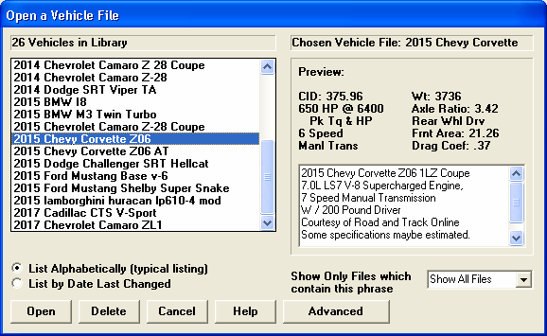
Figure A12 New Vehicle Files
Many new later model vehicles have been added.
Newer vehicles can now accommodate up to 10 speed transmissions.

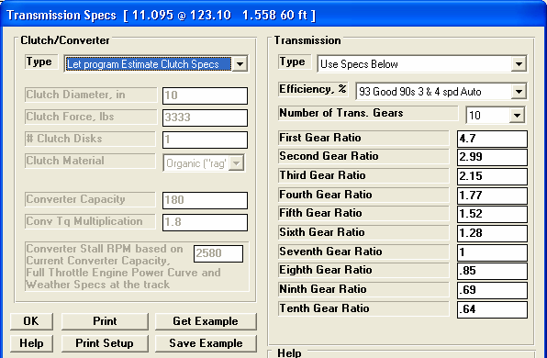
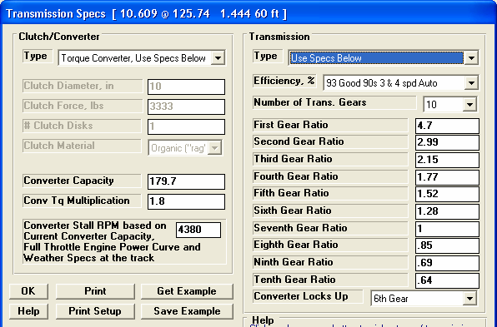
Figure A13 New Transmission Specs
You have the option of picking a gear at which the converter locks up (no slip). All gears above this are also locked up.
If you specify an automatic transmission, by picking a Torque Converter Type….
Your choice here will determine how many gear ratio inputs are displayed. In this case it is 10.

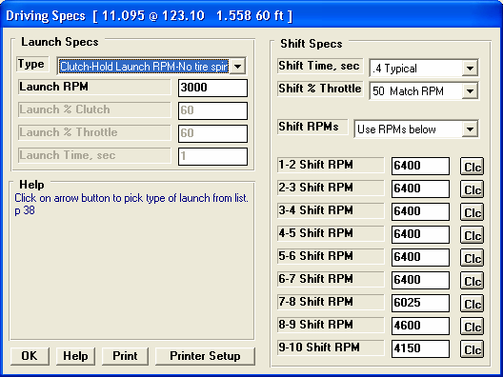
Figure A14 New Driving Specs
Because there are now up to 10 transmission ratios, there are now Shift RPMs available for all 10 gears.

Graphs are obtained by clicking on the Graph button or the Graph name in the menu bar at the top of the tabular results screen shown in Figure 3.2, Chapter 3. Figure A15 below shows a typical graph and descriptions of some of the basic graph screen items.
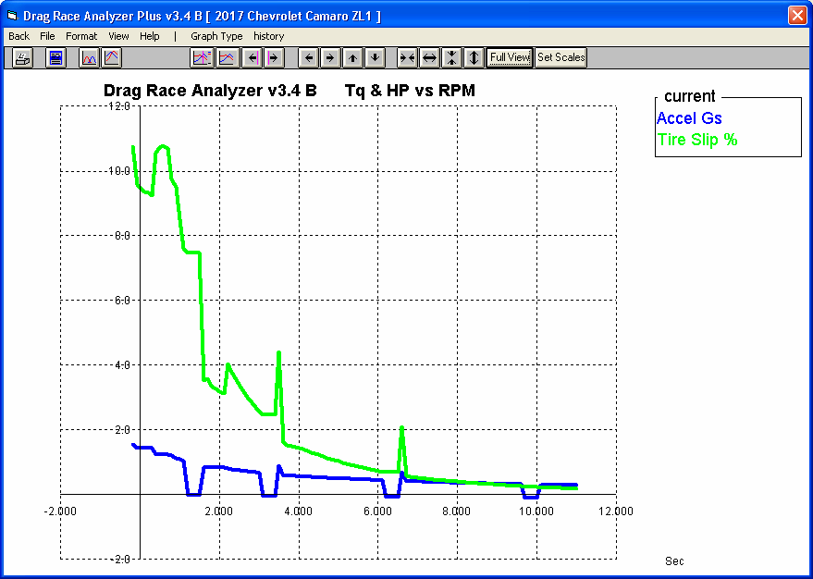
Figure A15 Basic Graph Screen Items
Command buttons perform action as pictured with 1 click of mouse.
Menu bar provides for several graph commands and options. Commands to the right of the “|” provide a short cut to commonly used commands.
Graph Title: change by clicking on Format, then Edit Titles/Legend. ‘Short cut’ commands appear to the right of this bar.
Name of current Engine File
Graph Legend, which describes the data graphed. This includes Name of test results, Type of Data.
Names in the Legend can be changed by clicking on Format, then Edit Titles/ Legend.

Horizontal X axis. The scaling of this axis can be easily changed as described in this section.
Grid lines. The style or elimination of grid lines can be changed by clicking on Format, then Grid Style.
Data graph lines. The style and thickness of these lines can be changed by clicking on Format, then Line Style.
Vertical Y axis, the scaling of which can be changed as described in this section.
There are several types of data which can be graphed, including:
- Engine RPM
- MPH, vehicle speed in miles per hour.
- Clutch or torque converter RPM.
- Feet is the distance down the track.
- Accel Gs is acceleration rate in Gs.
- Engine HP is the amount of HP being delivered to the clutch converter. This is affected by Driving Specs, engine RPM, weather conditions, and the shape of the power curve.
- Throttle, % is the amount the throttle is opened, where 100% mean wide open throttle or full power. Throttle is affected by Driving Specs and can be limited to prevent tire spin.
- Clutch or Converter RPM is the input to the transmission.
- Tire Slip, % is the amount the tires are slipping. Even though tires have not broken loose, they can still be slipping up to 10-15%.
- Clutch or Converter Slip, % is the difference between Clutch or Torque Converter RPM and Engine RPM, expressed as a percent. If the clutch or converter are locked, this will be 0%.
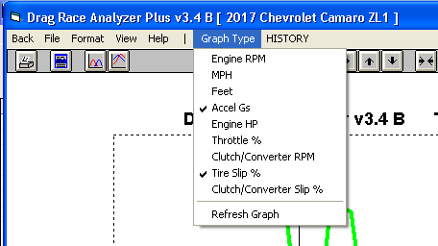
Figure A16 Data Types which can be Graphed

There are basically 2 types of graphs you can produce:
- Current test results. These are the test results for the data displayed in the Test Results screen, for the current Vehicle specs and conditions, the last run you made.
- Test results from the History Log. The History Log is a list of 25 tests, some of which you have specified you want saved long term, some of which are simply the last tests you have run.

The History Log is explained in some detail in Section 3.5 starting on page 105. This section will explain how to graph test results for tests in the History Log.

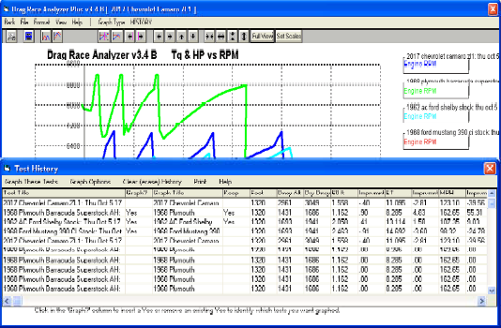
Figure A17 History Log for Graphing
Click on the History menu item to display the History Log shown below.
Click Graph Options, then Graph Single Test to just graph the Current Test Results.
Click in this column to show Yes or remove Yes. Tests marked Yes will be graphed.
Click on ‘Graph These Tests’ to close the History Log and graph the tests identified by the menu option you pick.
This column shows name program will display in graph Legend for this test. Click on name to change it.
Click and drag slide bar to display entire History Log. Some tests marked Yes may be at the bottom of the Log and not be visible now.
Other Graphing Features
The graph screen has several features, including:
- Printing
- Cursor to pinpoint the value of a particular point on the graph
- Changing titles and legend names
- Changing the scales
- Miscellaneous Format Options to change the appearance of the graph.

These are discussed in this next section.

Printing

Figure A18 shows the options for printing graphs and how to access these options. It also shows the screen for changing the Windows Printer Setup.
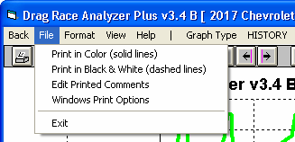
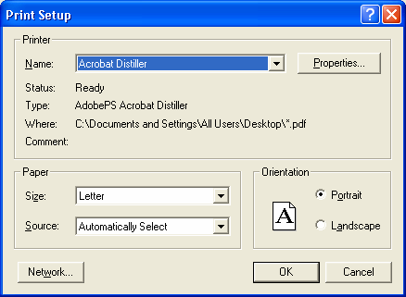
Figure A18 Printing Graphs
Clicking on the Printer button is the same as clicking on File and then Print.
Click on File to display the two print menu options

Click here to print the graph.

Click here to change the printer or
printer driver, page orientation, etc. as shown below.

Windows standard Printer Setup menu

Cursor
The cursor feature is very useful for determining or comparing the value of the graph lines at various places. See Figure A19 for explaining the use of the cursor.
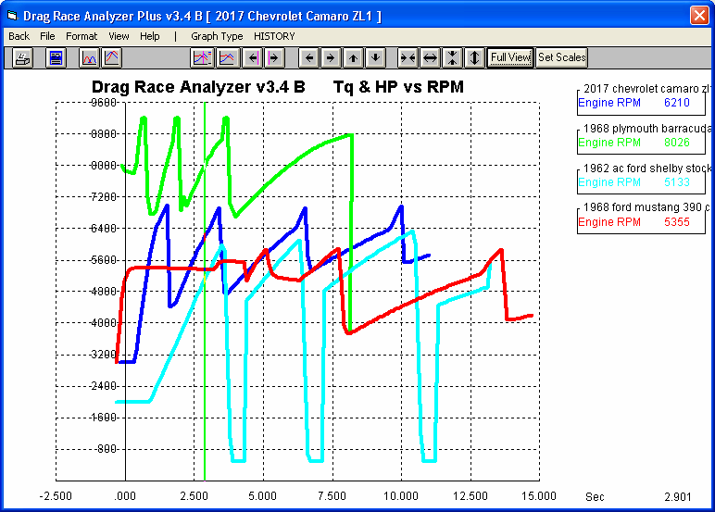
Figure A19 Cursor Features and Commands
Click here to turn Cursor On
Cursor line,Click here to turn Cursor Off
usually pinkClick on these buttons to move the cursor left or
or green,right. Hold down the <shift key> while clicking
depending onthese buttons and the cursor moves farther.
backgroundYou can also enable the cursor by clicking on View, then Turn Cursor On.

The value of each graph line at the cursor is displayed here.

The X value of the cursor is shown here, in this case the 2.901 seconds.

You can also enable the cursor by single clicking on a graph line. This also provides a quick way to move the cursor from 1 area of the graph to another. (Do not drag the mouse while clicking or you will zoom in on that area.)
Changing titles and legend names
Many times you may want to customize a graph by printing labels of your choice. Click on Format and then Edit Titles/Legend to bring up the menu shown in Figure A20 which will allow you to do this.
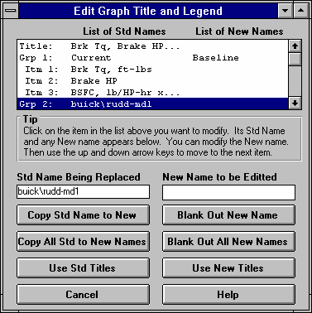
Figure A20 Menu to Edit Title and Legend
This is the list of Standard names the program uses unless you click on the Use New Titles button below. Select (click on) a Standard name you want to change. The Standard Name appears in the edit box, along with the current New name if there is one. Once you have selected a name from this list (that row will be highlighted) it is easier to use the up and down arrow keys to select the next item to edit than clicking the item with the mouse.

This is the list of New names the program will use if you click on Use New Titles. If a title in the List of New Names is blank, the program will use the Standard name.

Standard name from row selected.
New name for you to edit. Other options include clicking on the Copy Std Name to New or Blank Out New Name buttons.
Click here to close this menu and use the New names you have entered. Where New names have been left blank, the Standard name will be used.
Changing the scales
Many times you may want to change the scale of the X or Y axis. This may be to show an area in more detail or to match the scales of a previous graph. The Drag Racing Analyzer has several ways to change the scales as shown in Figures A21 and A22.
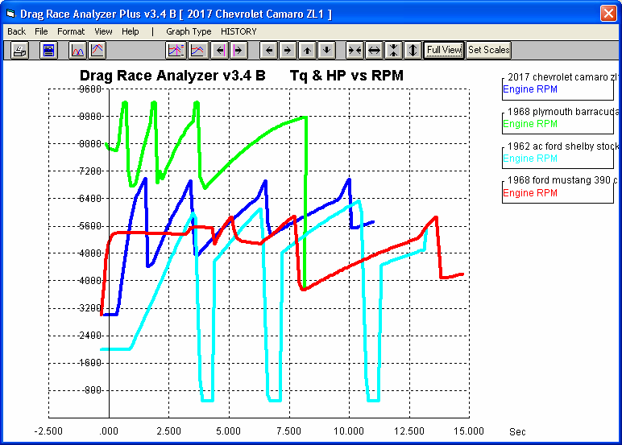
Figure A21 Changing Scales for the X or Y Axis
Clicking on these buttons zooms in or zooms out on the graph, either vertically or horizontally Hold down the shift key to produce faster action
Clicking on these buttons shifts the graph left, right, up or down. Hold down the shift key while clicking produces faster action.
Click here to restore “auto-scaling”. That is where the computer picks the scale to show all the graph in good detail.
Click on View, then either Zoom or Specify Scales (axes), or the Set Scales button to obtain the menu shown in Figure A22 on the next page.
You can use the mouse to outline an area to be zoomed in on. Simply click on the mouse key in the upper left corner of the area, then hold the key down and drag the mouse to the lower right corner of the desired area. A box will be drawn as shown. When you release the mouse key, this area will fill the whole graph. This feature is disabled if the cursor is turned on. Also, start the upper left corner well away from a graph line or the program may turn on the cursor instead.

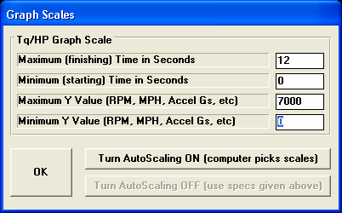
Figure A22 Menu to Specify Graph Axes Scales
This menu can be obtained 2 ways. You can click on View in the menu bar then Specify Scales (axes), or click on the Set Scales button, the right most button on the screen. See Figure A21.
The current scale limits are loaded when this menu opens. Change any or all these to most any value you want.
Click on OK to have the graph redrawn to these new scale limits .
These buttons determine if these scales are used, or graph is “auto-scaled”.

Format Options
Click on the Format menu item to be presented with several options which will be briefly discussed here.

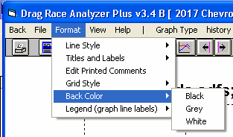
Line Style
Figure A23 Format Options
Click on Line Style to change the thickness of the graph lines.

Titles and Labels
Click on Titles and Labels to bring up option screen shown in Figure A18. See choices shown in Figure A22.
Edit Printed Comments
Click on Edit Printed Comments for the screen shown in Figure A23. These settings only affect printouts.

Grid Style
Click on Grid Style to change or omit the drawing of grid lines on the graph.

Back Color
Click on Back Color to change the background color of the graph from white, black or gray. Different Back Colors can make certain line colors stand out better, so experiment with your particular computer display and Line Style (thickness).
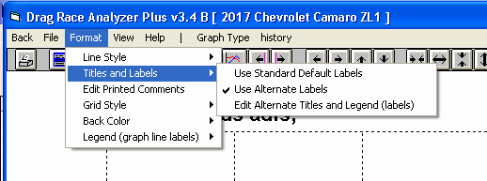
Figure A24 Titles and Labels

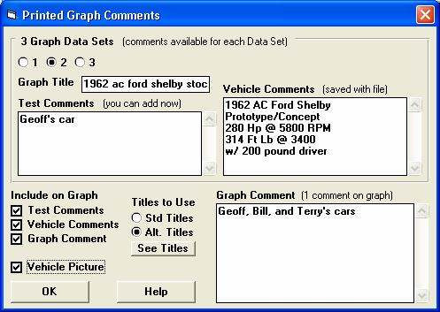
Figure A25 Edit Printed Comments
See Figs A26 and A27 for how these options appear on the printouts. As you click on these, different comment fields become enabled.
See Figs A26 and A27 for how these comments will appear on the printouts.
If you have 3 files marked to Graph in the History Log, you will have 3 option choices here. Click here to see the comments for each test to graph.

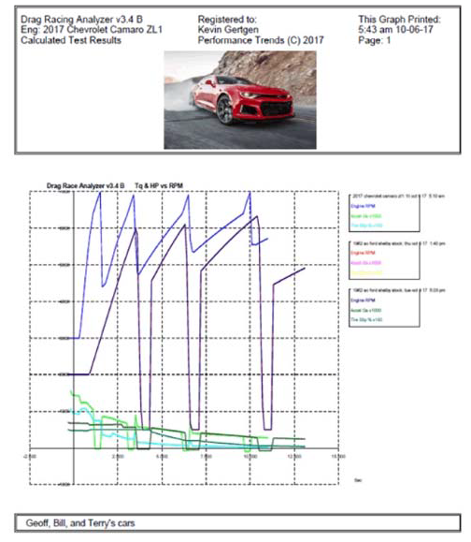
Figure A26 Graph Printout with Printing Options
Graph Comment goes here, just printed once for describing the entire graph, not individual fles.
Checking Vehicle Picture option puts picture file here.

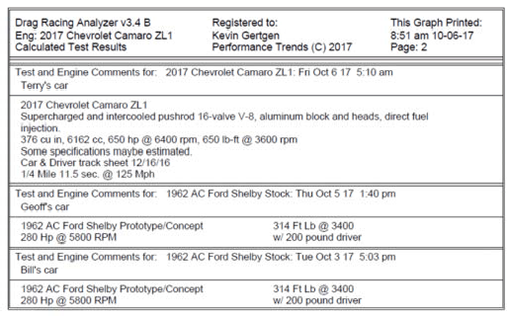
Figure A27 Graph Printout with Printing Options, cont
File Comments, which are the comments you enter on the main screen, and are saved with each vehicle file.
Test File Name and Test Comment for 2nd test marked Yes to Graph in the History Log.
File Comments for the 2nd test marked Yes to Graph in the History Log.
Test File Name, with run time and date.
Test Comment. These are entered in screen of Fig A25 and can be anything you want.

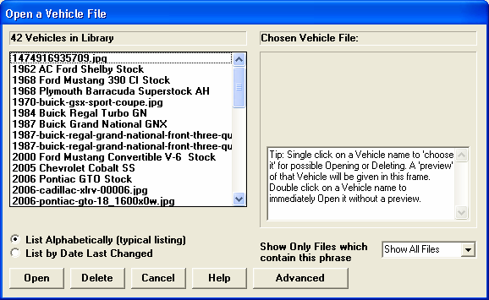
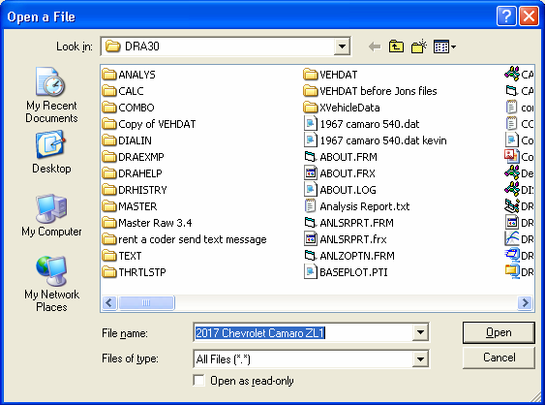
Figure A28 New Advanced Button For Opening and Saving Files
Standard Windows browsing window.
Advanced button opens up a standard Windows Browsing window so you can save or open to any spot on your

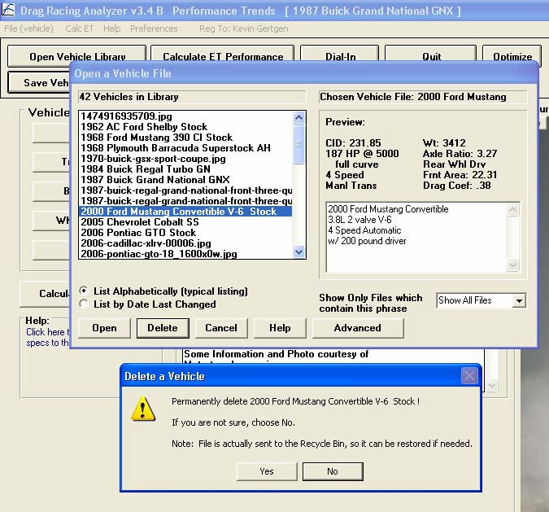
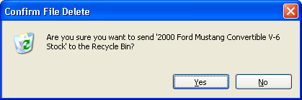
Figure A29 Deleted Files now go to Recycle Bin
Program again confirms it is going to the Recycle Bin.
Program asks you to confirm deleting, and says it will go to the Recycle Bin.
Click on a file name to highlight it, then click the Delete button to delete it.

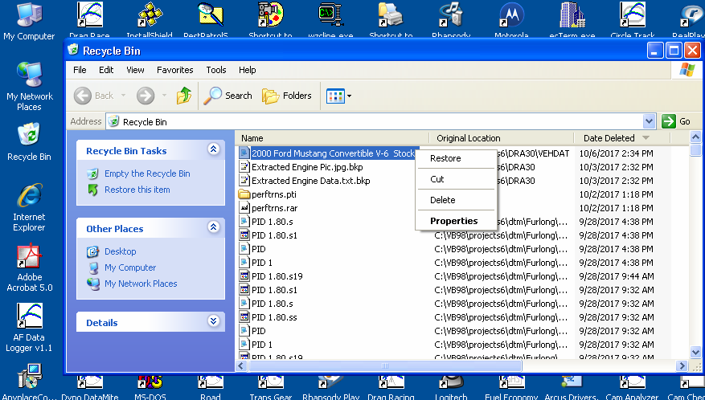
Figure A30 Retrieving Deleted Files from Recycle Bin
Find the file to restore, right click on it and select Restore and it will be restored to your list of vehicle files so you can again open it inside the Drag Racing Analyzer.
If you need to bring back (restore) a file you have deleted by mistake, open the Recycle Bin icon on your desktop.

